Lesson Thirteen: In Jerusalem for the Feast of Tabernacles
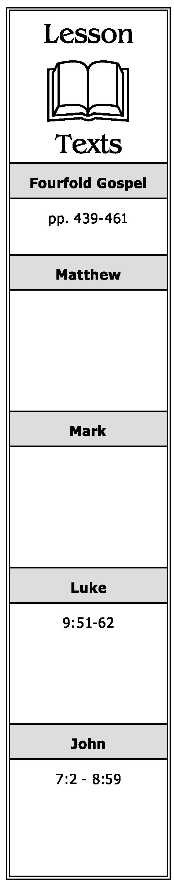
Jesus’ Brothers Advise Him to Go to Judea (John 7:2-9)
- What was the attitude of the physical brethren of Jesus toward Him at this time? Why did they encourage Him to go to the feast? What was Jesus' response to them?
- What reason did Jesus give for the fact that the world “hates” Him?
The Private Journey to Jerusalem (Luke 9:51-56; John 7:10)
- When some Samaritans rejected Jesus, what did James and John suggest that Jesus do to them? What was Jesus’ reply?
As to Sacrifice for Christ’s Service (Luke 9:57-62)
- What was the response of Jesus to the one who said he would follow Him wherever He went?
- How did Jesus respond to the one who would follow Him but first wanted to bury his dead father? What did Jesus’ answer mean?
- Why is one who has “put his hand to the plow” and then looks back not “fit for the kingdom of God”?
In the Temple at the Feast of Tabernacles (John 7:11-52)
- Why did the people at the feast not speak openly of Jesus? What different views did they have of Him?
- What answer did Jesus give those Jews who marvelled at His teaching seeing that He knew “letters, having never studied”?
- Knowing that their leaders wanted to kill Him, what question did some of the Jews ask among themselves? What was their view of Jesus?
- After telling the people that they did not know the God who had sent Him, what did Jesus say about His own knowledge of God?
A Chronological Study of the Life of Jesus Gene Taylor 37
- Why did the Jews seek to “take” Jesus? Why were they unable to do it?
- What question was asked by the people who believed on Jesus?
- When the Pharisees sent officers to take Jesus, what did He tell them? What questions did the Jews ask among themselves as a result of Jesus’ statement?
- When the officers were questioned as to why that had not brought Jesus to the chief priests and Pharisees, what was their response?
- Who was Nicodemus? What did he ask of the Pharisees? What was their reply?
The Story of the Adulteress (John 8:1-11)
- Briefly summarize this event. Why did Jesus not condemn her? Was He condoning sin? Explain.
Messianic Claims Met by an Attempt to Stone Jesus (John 8:12-59)
- After telling the Pharisees that He was the light of the world, what did Jesus say in reference to those who follow Him?
- Briefly summarize Jesus’ explanation that the testimony that He gave of Himself was true. How could it be the testimony of “two men”?
- What did Jesus say was needed if one were not going to die in his sins? Why?
- When did Jesus say that the Jews would “know” who He was?
- Who, at first, did the Jews claim as their father? Who did Jesus say their father was? Why?
- Why did the Jews say that Jesus had a demon? What did they ask in reference to Abraham?
- What, according to Jesus, is His relationship to Abraham? What is meant by the phrase “I AM”?
- Upon hearing the above teaching, what did the Jews do? What did Jesus do in response?
A Chronological Study of the Life of Jesus Gene Taylor 38

